LAB BOOK1

MANPREET KAUR

8701234

INFO 1385

Professor’s Name

2021-09-01

# Table of Contents

Table of Contents 2

Lab 1 – Spanning-Tree Configuration 3

Description 3

Screenshots 3

Reflections……………………………………………………………………………………………………………………………….……11

References…………………………………………………………………………………………………………………………………….12

Lab 2 – VLAN Spanning-tree Configuration 12

Description

Screenshots

Reflection

Reference

Lab 3 – NIC Teaming Configuration 12

Description

Screenshots

Reflection

Reference

# Lab 1 – Spanning-Tree Configuration

## Description

This lab will result in a switched network. The goal is to observe how STP works, how to establish/force a root bridge, and how to identify roles and states of ports involved.

## Preparation

* Checked the Packet tracer software running.
* Ensured that the IP addressing scheme used for topology is correct.
* Ensured that the correct objects switches (2960) are to be used.

Observation

* Build the topology with three 2960 switches as access switches and a 3560 switch as a distribution switch as per the given instructions
* Connect the switches as they are creating a physical loop.
* Run the command ‘show spanning-tree’. This command will show the details of BridgeID, Root ID and the neighbors.
* To set the Root bridge, run the command on distribution switch ‘spanning-tree vlan 1 priority 4096’. This command will make the Distribution switch as a Root Bridge.
* Run the command ‘show spanning-tree’ to verify the impact of previous command.
* Observed the status of all the interfaces after the STP converged.

## Screenshots

Part 1.

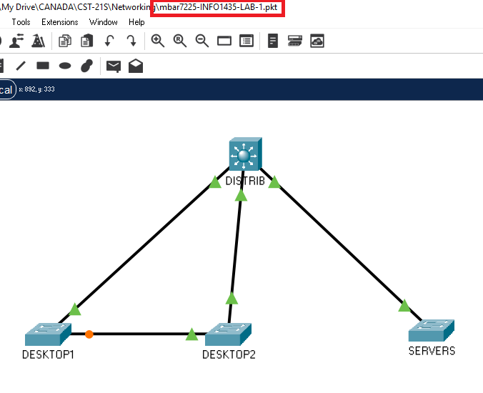

Fig. 1 – SPT Topology

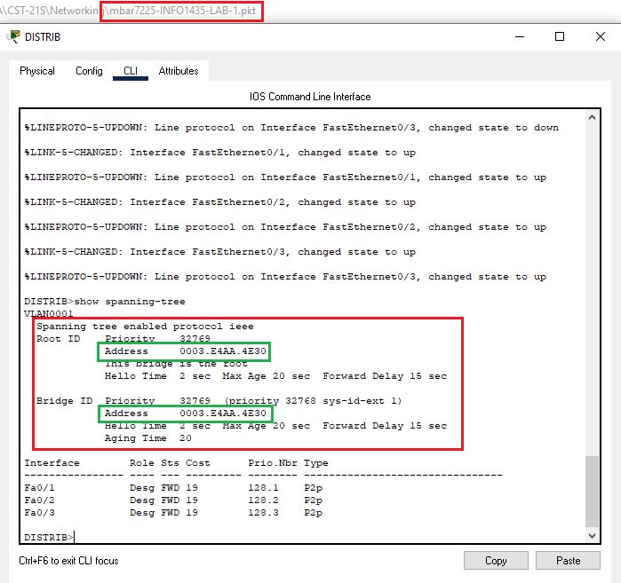

Fig. 2 – Distribution switch

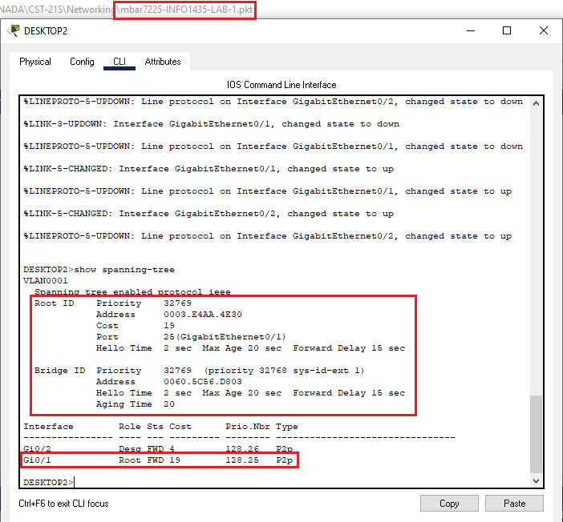Fig. 3 – Desktop2 switch

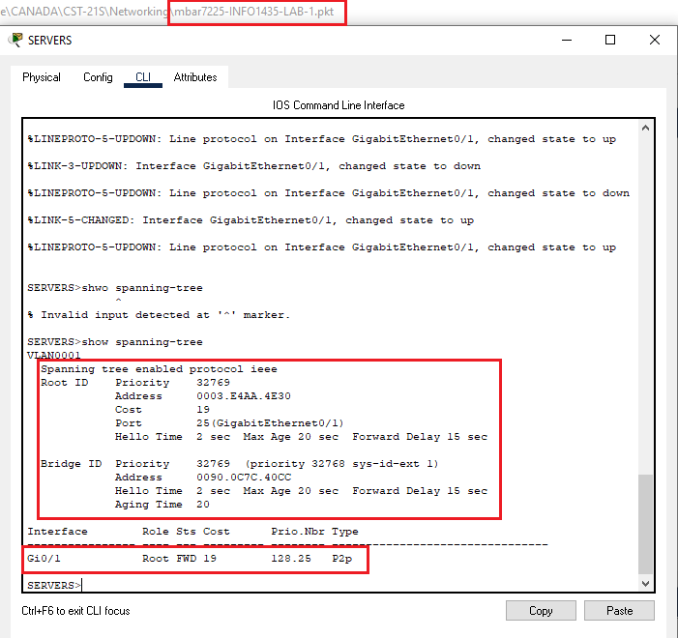

Fig. 4 – Servers switch

Part 2.

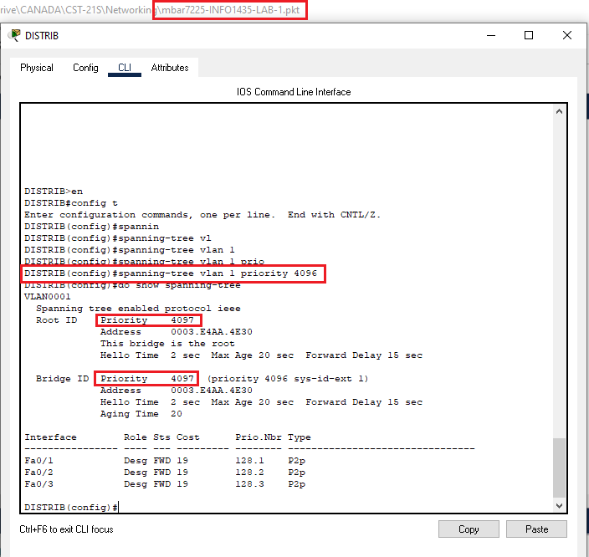Fig. 5 – Forcing Root bridge

Part 3.

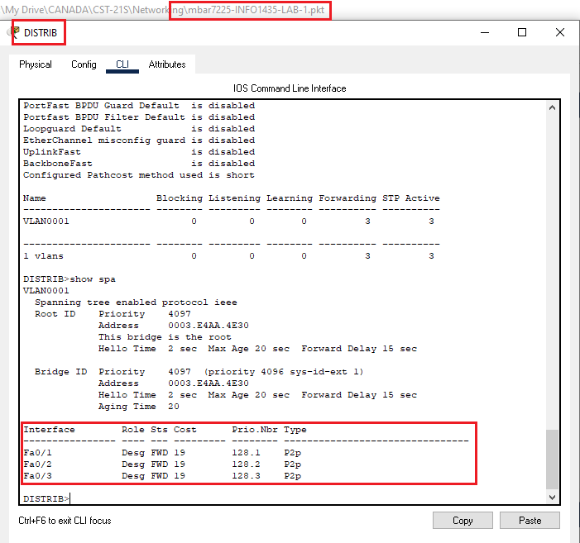Fig. 6 – Role and state on Distribution switch

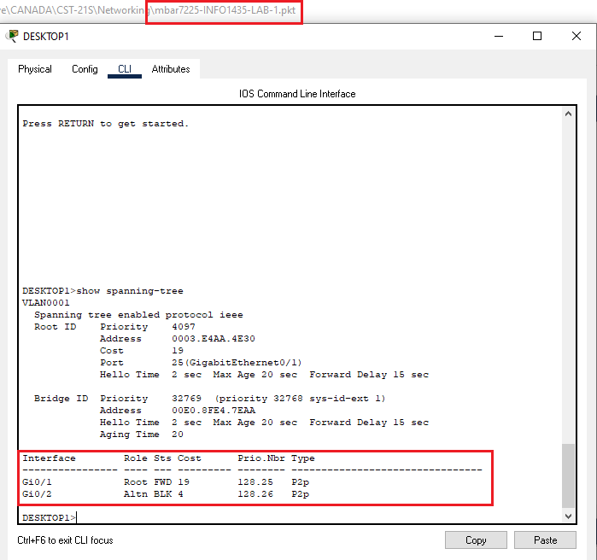Fig. 7 - Role and state on Desktop1 switch

Reflection

Part 1.

After entering the command show spanning-tree on each device, there are a couple of ways to figure out which one was determined as a root bridge. At first, as all the devices have the default values and priority, the calculation of STP will evaluate the MAC Addresses values to determine the lowest between them. In this case, Distribution Switch was defined as a root bridge (see Fig. 2). Another form to know which device is the root bridge is taking a look down in the screen result below the tag "Role". It will show if any port on the current device is connected to a root bridge (see Fig. 3). If is not, it is a good clue that the current device is the root bridge.

Part 2.

As in this scenario, the initial result of spanning-tree calculation determined Distribution switch as a root bridge. In order to ensure that it remains so, we need to lower the priority value. To do so, I ran the command spanning-tree vlan 1 priority 4096(see Fig. 6). As a result, the priority value was updated and reduced making it the lower. Whether any other device is replaced, the Distribution switch will remain as the one with the highest priority (lower value)

Part 3.

After running the command show spanning-tree once again, the results are focused on the role and states of the ports on each device. In part 1, I mentioned that it could give us an idea of which device is the root bridge, but let's go further to understand the meaning of each.

First, we need to understand the different roles.

Root Port:

It is the port with the lowest cost path to the root bridge. There is only one root port per switch, and all the frames forward through root port.

Designated Port:

All ports in the root bridge device are designated ports, and all of them forward the traffic

Backup Port:

It is an alternative path connected to the root bridge using the same type of port (FastEthernet or GigabyteEthernet).

Alternate Port:

It is an alternative path connected to the root bridge using a different type of port.

Now Let’s talk about states

Forwarding: traffic flows through these ports

Discarding: Listening mode. No traffic

Learning: Learns and builds MAC Address table. Part of the convergence process

Converged: all ports in final state

## Reference

Odom, W. (2016). CCENT/CCNA ICND1 100-105 Official Certification Guide, First Edition. <https://learning.oreilly.com/library/view/ccentccna-icnd1-100-105/9780134440903/>– PVST

LAB 2

Follow the same format as shown for Lab 1

LAB 3

Follow the same format as shown for Lab 1